User Manual program ForDiag

Installing driver interface / cable

- Insert the included CD into the drive and install the program

- Insert the connector of the USB interface to PC

- Wait until the system does not install the device driver

Program settings

- Run the program ForDiag

- select "Settings"
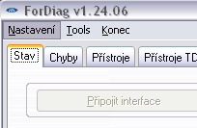

- In the settings window select "Search interface"
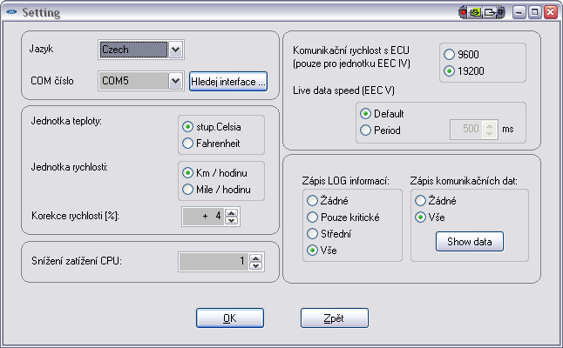

The program will search through all available COM ports If the driver interface installed properly, interface will be found and the following message will be displayed::

- Press "OK" to confirm

- a window to save your settings: press “OK“

What if you do not find the interface:

For proper operation interface driver must be installed. In most cases, it will install the driver automatically when first plugged into the USB port interface. (No need to have the OBD connector plugged in. Interface is powered from the USB port.) However, if the driver installation fails for some reason, it can be done manually.

• Remove the interface from the PC

• Start from the enclosed CD in the folder Driver installation file "CDM20824_Setup.exe"

Alternatively the latest driver can be downloaded from the forum.fordiag.cz websit (http://forum.fordiag.cz/viewtopic.php?f=14&t=3)

To continue the installation process

• Connect the interface to the PC

• After a few tens of seconds the system should display the information in a message box saying "the new device is ready to use"

• Repeat the attempt to find the program interface ForDiag

Connect with ECU unit of a vehicle

- Select the type of vehicle automakers from the list of supported auto makers. Select the type of vehicle

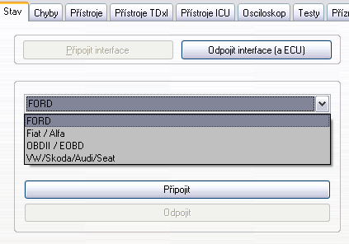

- Then select the type of unit (Engine = motor, etc.)

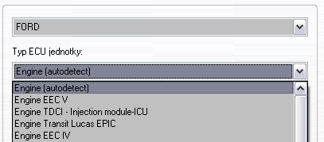

- Press the button. "Connect"

The list of supported types of units:

Engine (autodetect) – motor drive (connected to the CAN bus, bus or PWM)
The program will perform a search motor units on both buses, but does not search older units EEC IV!

Engine EEC IV -special item for connection to the motor unit over gasoline cars. 16v/1.8 Escort 1.6 16v, 1.4 CVH ...
In the case of units EEC IV can not use the automatic detection and therefore it is necessary to select this item.

SASM – steering … - module sensing the steering angle

TRM – trailer module
EATC – Climate control module, etc.

Quick Tabs / screens of the program:

State

This is where you select the connected ECU and displayed here identified Learn about ECU

Errors

The screen is used for reading and erasing stored in the ECU errors (DTC - diagnostic trouble code)

The equipment - primarily for gasoline engines

To activate the screen should be run "live data" button Start. Before moving on to other activities (eg reading errors) should live data first stop printing. Stop.

Testers Lambda sensors bank 1 and 2 - voltage of lambda probes 11 and 21 (before catalytic converter) Richness Lambs - value indicating the current richness in multiples of excess air. Thus, a lower number than 1 = rich mixture, a higher number than 1 = lean.
LED LAMBDA - (open loop / closed loop) - open / closed loop
Green indicates a closed loop - regulates the richness of the mixture, using the lambda probe
Red color - open loop - the richness of the mixture is given a fixed setting and long-term adaptation

AM1/AM2 – only for EEC IV units - Heating System catalyst and lambda probe after a cold start

IMRC ON – activation of the intake valves changes

Devices TdxI

The screen is primarily intended / preconfigured for diesel engines TD, TDDI and TDCI.

To activate the screen should be run "live data" button Start. Before moving on to other activities (eg reading errors) should live data first stop printing. Stop.

Devices ICU

Screen module designed specifically for the ICU injection device Delphi system TDCI engines (Mondeo MK3, MK1 Focus, Transit older generation).
You can live here to see the detailed data relating to the control of high-pressure pumps (IMV valve), his adaptation, balancing idle adjustment assistance benefits in individual cylinders, individual cylinder knock level, etc.

Watching live data in a graphical view

First, enter the value specified for monitoring the PID (parameter identification). You can select up to 2x 4 values​​.
Selection of values ​​is done by pressing the "down arrow" in the lines "value 1", "value 2"
…

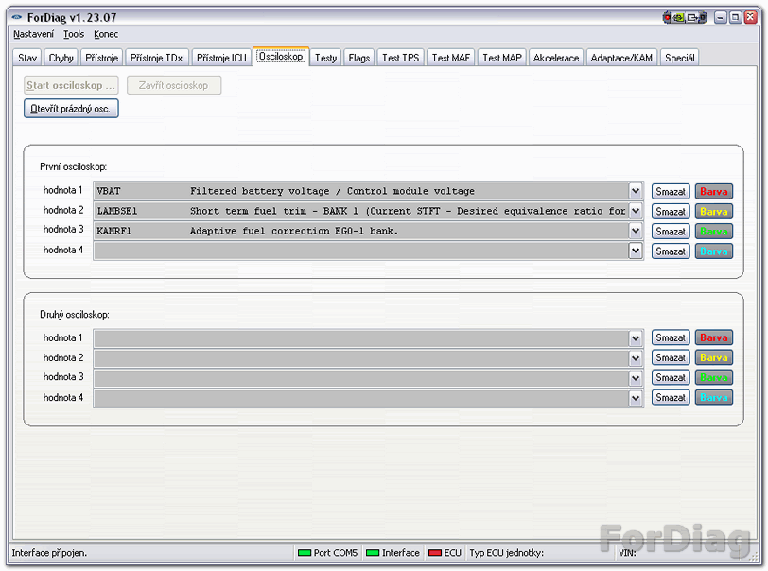

After selecting values ​​can be monitored by pressing the key. "Start oscilloscope" start displaying a chart with values. It will open a separate window with a graphical display.
If you select only the first four values ​​will be displayed in a graph with four values. If you fill in some values ​​and to the other four, two graphs are shown below.

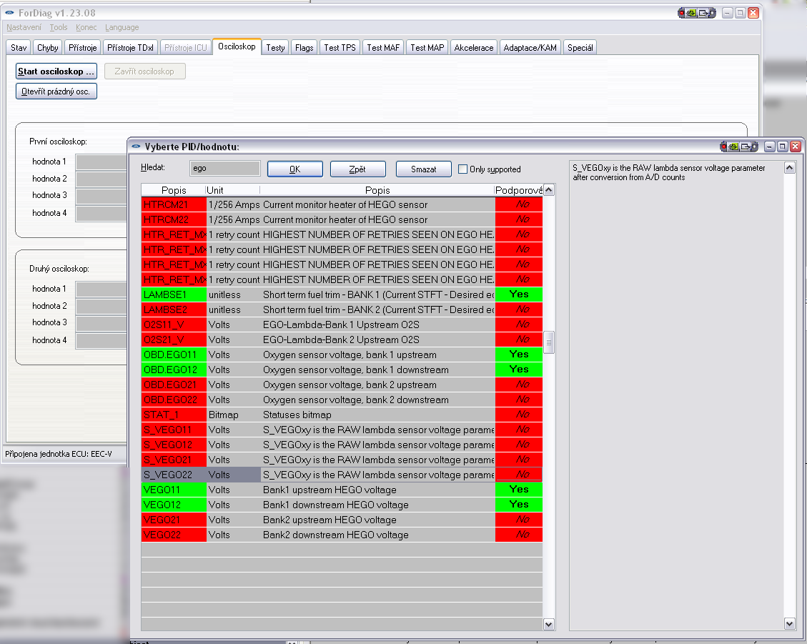
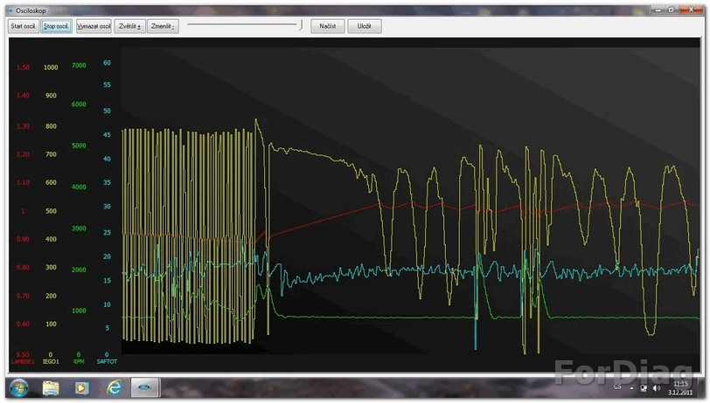
Tests

Test KOEO and KOER (mainly for gasoline engines)
Internal tests (after you start using diag. Implementing it alone ECU) many actuators, lambda probe etc. Test KOEO is done in stop mode engine test Koerich mode started by the engine.

Test KOEO
- The engine should be at operating temperature

Test KOER

- The engine should be at operating temperature
- -The automatic transmission is necessary to select a position switch "Park"
- During test is required spin control to one of its extreme positions (for verification sensor increased pressure in the power steering system), if the operator does not this action will be recorded in the registry of errors error P1650, or P1550 ((PSPs) outside the scope of the self-test)
- -During the test required short press the accelerator to the maximum position (for verification sensor TPS-throttle rotation)

Test Unit output
Possible activation of most motor actuators separately + activation of cooling fans. The engine must be stopped, only the ignition on.

The "All On" - a few seconds is on most motor actuators, such as: heating lambda probes, idle valve open, open EGR valve, exhaust valve opening for the tank .... But they are not open to the fuel injection valves (for security reasons).

The "All On" - will shut down all output circuits ECU, as well as those that are different or on (heating lambda probes, ...)

Flags

Reading data from the ECU conditions / monitor individual circuit (output faults) and state of an individual. control algorithms (failure flags).
To activate the screen should be run "live data" button Start. Before moving on to other activities (eg reading errors) should live data first stop printing. Stop.

Test TPS

Preconfigured screen test TPS sensor Throttle.
Ratchet value is the value of "lowest recorded value of TPS." ECU uses this value to determine the position of the throttle valve closed.
If the value Ratchet significantly lower than the value of the TPS may be a symptom of faulty sensors TPS or cabling. The lower value in Ratchet implies that this value sometime in the past (since last start) in circumference TPS occurred.

Test MAF/MAP

These tabs are used for rapid control (operator) values ​​provided by the sensors MAF / MAP.
The MAF sensor is advantageous to capture the maximum values​​. General (simplified) can be assumed that a properly functioning MAF should provide an output voltage of approx. 4V at maximum air flow. If the maximum value reaches approximately this value, the sensor is dirty / damaged
/ ...
To activate the screen should be run "live data" button Start. Before moving on to other activities (eg reading errors) should live data first stop printing. Stop.

Test can be done easily even when the vehicle is stationary - short sharp throttle until the engine reaches its maximum speed.

Adaptation / KAM

The feature is intended only for gasoline engines. It is the possibility to read and display adapter table mixture.

Unit as one of the basic activities calculates the required amount of fuel injected.
This amount must be (in normal driving situations) such that as closely as possible the ideal mixture of gasoline and air. This ratio can say Lambda = 1.0

Viz. http://en.wikipedia.org/wiki/Air-fuel_ratio (EN) nebo
http://www.ngk.de/cz/technicke-detaily/lambda-sondy/zakladni-vedomosti-o-emisich/koeficient- prebytku-vzduchu (CZ)

When the mixture ratio of gasoline to air emissions are the smallest and it is primarily an engine manufacturer.
To determine whether the mixture is rich or poor uses a Lambda sensor. Commonly used lambda sensors are not able to provide information on the ideal mixture of 1.00, but are able to recognize the state where the mixture already rich, already poor, or vice versa. The unit thus regulates so that they are constantly varying the amount of injected gasoline around the ideal mixture alternating enrichment and ochuzovanim. When the lambda sensor system reports "mixture is too rich", the unit starts to slow gradually impoverish mixture until such time as the lambda sensor begins reporting "lean mixture". And so on. The required amount of fuel injected can be roughly computed based on the values ​​of sensors on the engine, especially the MAF (or MAP) sensor, rotational speed, etc. but the calculation can never be 100% not accurate. Each engine has some deviation from the ideal, some has even pricpany fuel filter, some exhaust pipes, etc.
That motor was still working (because of emissions) in an ideal mixture in 1.0 lambda is necessary to introduce corrections. The unit also maintains a "correction value" where he notes how much the calculation mixture "washed" from the actual desired compound. This correction of the notes on the basis of the reports true from the lambda sensor.

What is the shelf where one axis is the engine speed in the second axis are percentages? Percent of what? The correction value can not be but only one for the whole operating range of the engine situation. Therefore, the introduction MAP correction. For different engine speed and loads are maintained by different values.
So it is a chart where one axis of the engine speed (X) and the second axis motor load in% (Y). Ford which used the 10x10 table cells, the younger squads are only 8x10 cells.

What values ​​should have an optimal adaptation show?
Software ForDiag shows the percentage CORRECTION, so the ideal value is 0.00 in this case, the ECU just "feeds" the desired compound.
ECU first calculates how much fuel to inject mela, but the result still applies "adjustments" of the adaptation table. Find out who the cell has adaptive value marry (dano speed / load) and calculated values ​​still [color = # FF0000] multiply [/ color] The number of cells dane adaptation. Thus, if the number like 1.1, raises the supply of gasoline by 10%.
If the number is 0.9, reduce the dose by 10%.
Ford ECU allows changing the idle mixture a maximum of 25% (This can vary from the motor) to nedochazelok fact that when an undetected failure of any sensor will mistakenly mixture edit and beyond where the mixture zapalitelna ...

Why are adaptations of off-center the map to zero?
ECU does not write a value to each and every cell in the map seperatly. In some states of the motor (cells) may use the values ​​of any adjacent cells. ForDiag umi clean the values ​​of all cells, but can not (on screen) values ​​of cells used to take photocopies of cells which, in fact I draw value from elsewhere. Even so, the adaptation map very informative. ForDiag shows all used cells. The remaining cells that contain the ideal value of 0 are either really in an ideal state, or one of the cells for which the entity has not yet been forced to form adaptation (ie 100% load at 1000 revolutions is unreachable), or is a cell that is not used and the ECU at this speed / load applied by some near another cell.

The cells in the lower separate of rows.
ECU maintains a quite separately special adaptation cells just for idling. (This does not apply to Duratec engine, there is the idle seems to be using one of the "normal" cells.) Again seperatly stores cells for different states idle. Another cell uses when air conditioning is on (and thus increase engine power), another for neutral or in gear in Auto

Transmission, ...

Practical use of enumerated values ​​adaptations:

Eg. If you are a high number of adaptation mainly In the upper range of engine load, it means that the ECU is forced adds a lot of fuel in a situation where it is also a lot of need (heavy duty) and therefore it points to the insufficient supply of fuel = clogged fuel filter, clogged injection or weak gas station.

Another example: When the high adaptation especially at idle and low speeds, this indicates air leak somewhere on the side, which does not measure the MAF sensor. At low power (like idle) will also affect male sucking in air, whereas in heavy load, the error in the measurements is no noticeable because the engine sucks in more air many times.

Special – TDCI injectors

You can write the calibration C2I code (s) injector (s).

The tab is enabled only for TDCI engines fitted with Delphi (MK3 Mondeo, Focus MK1) and only after connecting the unit "TDCI Engine - Injection module - ICU".

Press "read" can be read / view C2I codes currently stored in the unit. Code reading function is only available for a younger version of Delphi (since about 2002) (see technical manual injection Delphi [9])

  - Writing code is done in the mode is switched
  - writing is individually and can be written separately for any number of injectors
  - attention to the numbering sequence - is different from the numbering cylinder!

Special - Memory Unit / Test PIDs / Bus scan

These functions program-makers to determine the specific characteristics of individual control units.

List of references:

[5] http://forum.fordiag.cz/viewtopic.php?f=15&t=4

